**ASP.NET Core Workshop**

**ADO.NET**

# Requirements

In this workshop, we will create a simple web application using ASP.NET ADO.NET with the following features.

1. When the users access /Course, the app displays a summary of all courses.

1. When the users click on the **Details** action above, the details of the respective course will be displayed.

1. The app can also display a summary of all lecturers.

1. It also displays all courses the respective lecturer teaches.

# Prepare Code

## Option 1

Follow the steps in the given videos.

## Option 2

1. Download, unzip and open solution **ADO.NET Example** from **ADO.NET Workshop Start.zip**.
2. Run the **ADO.NET Example** project
3. In the browser, launch the /Course, for example: <http://localhost:7209/Course> (change port number accordingly)
4. An exeption like what is shown below is thrown in class **CourseData** (could you explain why?)

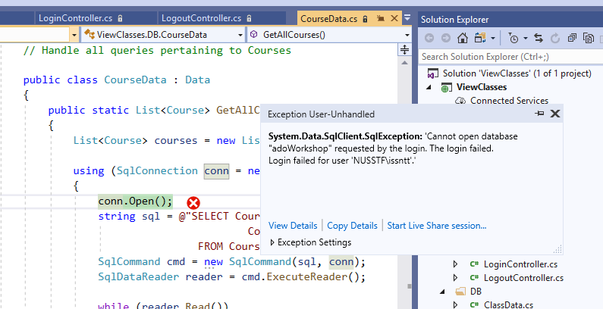

# Prepare Database

1. Open Microsoft SQL Server Management Studio.

Remember location of the **Server name.** We will need to copy the string of server name later.

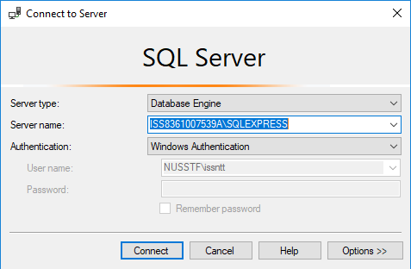

1. Click Connect.
2. Create a new database named **adoWorkshop**.
3. Select the new database, create a table named **Course**, with following columns

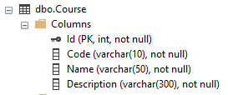

1. Input some data into the **Course** table. For example

|  |  |  |  |
| --- | --- | --- | --- |
| **Id** | **Code** | **Name** | **Description** |
| 1 | FOPCS | Foundations of Programming with C# | Write programs using C# with Visual Studio |
| 2 | OOPCS | Object Oriented with C# | Understand and program on main Object Oriented concepts |
| 3 | MVC.NET | ASP.NET MVC Programming | Understand and develop web applications using ASP.NET MVC |

1. In project ADO.NETWorkshop, open class **/Data/CourseData.cs**
2. Change the **connectString** value to to what is shown in the **Server name** on your SQL Server Management Studio.

**Note**: different versions of SQL Server use different strings. For example, Express version may need to include something like “<computer_name>\SQLEXPRESS”, while Developer vesrion only needs “<computer_name>”.

1. Re-run the ADO.NETWorkshop project, and test with the project URL <http://localhost:7209/Course> (change your port number accordingly) again.

The webpage should display the courses in the database.

1. Investigate the class **/DB/CourseData.cs** to see how ADO.NET is used to implement the features.

# Implement Features

1. Implement a feature so that clicking on the **Details** action above will display the details of the respective course.

1. Extend the web application above to store and list all Lectures.   
   Table **Lecturer** looks like this  
   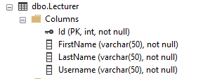

Create some mock data into your tables to help test your web application. For example:

1. Further extend the web application to store and list all courses a lecturer teaches. One lecturer can teach more than one courses, and a course can be taught by more than one lecturers.

Create some mock data into your tables to help test your web application. For example:

1. (Optional) Further extend the web application to add creating new courses feature.
2. (Optional) Further extend the web application to add searching courses by **Name** and by **Course Code**.